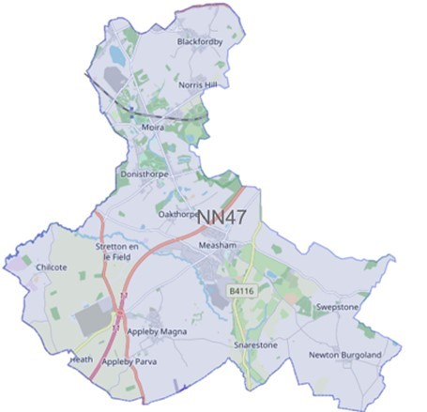

Issue: April 2024

Forest Beat

Newsletter

Your Local Team

What matters to you

SGT Aaron Bell

PC Russ Leech

PC Owain Jones

PCSO Maddie Fearn

We have listened to you and the concerns you raised and will prioritise the following in April 2024 through to June 2024

Priority 1: ASB – Moira Furnace
Anti-social behaviour at Moira Furnace in particular off-road bikes and drug taking.
What we are going to do: Complete targeted patrols to disrupt and challenge behaviour. Intelligence development. Challenge those involved and work with partner agencies to implement outcomes.

Priority 2: Drug Dealing
Drug dealing around the Oakthorpe area.
What we are going to do: Complete targeted patrols to disrupt and challenge behaviour - Intelligence development. Challenge those involved and work with partner agencies to implement outcomes.

Priority 3: Theft and attempt theft of vehicles in Moira and Donisthorpe
Vehicle crime in Moira and Donisthorpe.
What we are going to do: Complete targeted patrols to disrupt and challenge behaviour - Intelligence development

Please click the link to show the latest available crime figures in the Forest Beat Area, beat team information, policing priorities and meeting and events.
https://www.police.uk/pu/your-area/leicestershire-police/forest/

News

The Forest Beat would like to introduce our new Sergeant!
Sergeant Aaron Bell will be replacing Sergeant Gary Sirrell as the new Sergeant for the Forest Beat.
We would like to welcome Aaron and wish him all the best in his new role.

To read all the latest news please follow the link
News | Leicestershire Police (leics.police.uk)

Crime Prevention

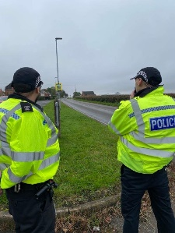
Visit our website for details on crime prevention https://www.leics.police.uk/cp/crime-prevention/
What we are doing
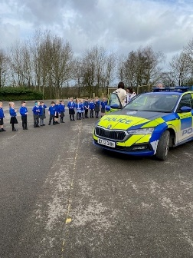
- Community Consultations to hear your views which assists us in priority setting in the future.
- Regular speed checks
- Regular patrols of hotspot ASB area’s
- Visiting schools, youth groups and community meetings
- Regular patrols of local park areas.
- We plan to be visible in crime hotspots across the area to reduce criminal behaviour.
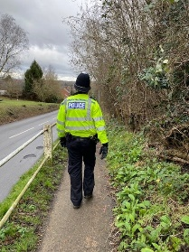

Please help the Forest beat to understand your concerns by completing the following surveys.
- Confidence Survey Your Views Survey

POLICE REPORT
Co-op Stores, Moira – theft of items
Shortheath Road, Moira – theft of 60 litres of cooking oil
Burton Road, Oakthorpe – theft of vehicle
Hart Drive, Measham – theft of vehicle
Sarahs Wood, Moira – Anti-social behaviour
Acresford Road, Donisthorpe – 2 vehicle RTC
Jewsbury Avenue, Measham – theft of vehicle
Miners Welfare Club, Moira – anti-social behaviour
Huntington Way, Meaham – theft of items from van
High Street, Measham – traffic cones stolen
Canal View Lane, Moira – attempted theft of vehicle
Measham Leisure Centre – theft of item
Blackfordby Lane, Moira – theft of items from inside motor vehicle
High Street, Measham – theft from store
Main Street, Albert Village – damage to vehicle
Main Street, Albert Village – attempt theft of motorbike
Moira Miners Welfare Club – Anti-social behaviour
Moira Village Hall – Anti-Social Behaviour
Snarestone Road, Appleby Magna – theft of tools
Conkers Camping and Caravanning Club – attempt theft of tools
The Green, Newton Burgoland – vehicles driving along a closed lane
Chapel Street, Oakthorpe – attempted burglary
Moira Furnace – Anti-social behaviour

We have seen an increase in theft and attempt car thefts around Measham, Moira and Donisthorpe. Please be assured this is one of our targeted beat priorities and regular patrols, particularly between the hours of 10pm and 6am are taking place around the area.
Having your car stolen or broken into and losing your things to thieves can be very distressing. Please see below for a few simple steps you can take to keep your vehicle, and what’s in it, safe.

1. Always lock it
Fuelling up or popping back into your house to get something are perfect examples of how easy it is to turn your back for a moment and forget your vehicle is unsecured. So get into the habit of locking your vehicle even if you’re only going to be away from it for a moment.
If your vehicle has wing mirrors that fold in automatically when locked, make sure you lock it properly. Criminal gangs are looking for vehicles like these where the wing mirrors are still out because it is clear to them that the vehicle has been left unlocked.

2. Close windows and the sun-roof to prevent ‘fishing’
Leaving windows and the sunroof open invites fishing for items through the gap by hand or with, say, a bent coat hanger, which could also be used to unlock a door for them to get in. Thieves can be ingenious. Don’t give them the opportunity.

3. Secure your number plates with tamper-resistant screws
The easiest way to change the identity of a stolen vehicle or avoid speeding tickets and parking tickets is to fit stolen number plates. Using security screws to attach your vehicle’s number plates makes it harder for thieves to get your number.

4. Fit locking, anti-tamper wheel nuts to secure alloy wheels
Stolen wheels are valuable, either as parts or for their scrap value. Using locking wheel nuts reduces the risk of your vehicle’s wheels being stolen.

5. Secure anything that’s on the outside of your vehicle
Anything left on roof-racks, tailgate racks, holiday top boxes or in tool chests are easily stolen when the vehicle is parked. The use of cable locks, padlocks and self-locking tools chests, which are secured to the vehicle, makes them more secure, but still, don’t leave things in them if you can avoid it.

6. Take it with you or hide it
Your mobile phone, coins for the car park, sunglasses, packs of medication or other items that can earn quick cash are irresistible to the opportunist thief. Remember, the cost of replacing a window is often much more than that of what’s stolen. And it should go without saying that wallets, handbags, purses and credit cards should never be left in an unattended vehicle.

7. Hide electrical items and leave no clues
Leaving sat nav mounts, suction cup marks on windows or cables on view gives it away that you have left a Sat Nav, smartphone or other device in your car. Even if they can’t see the Sat Nav or iPad they might still break in to see if it’s stored in the car, out of sight.

8. Tool theft from vans
Vans are often targeted by thieves for the tools stored inside. If you have to leave tools in a van overnight, it's a good idea to mark them clearly with your name / company name and address using paint pens and seal with a clear lacquer spray. Alternatively, you can use a variety of other property marking systems. Items that are clearly marked are less desirable and more difficult to sell on.
Consider using a lockable cabinet within your van to store tools – a number of security rated products are available. Small cameras are also designed to record inside vehicles.
You can also take photographs of items of value, make a note of the serial numbers and consider registering them online at a property register site.

9. Park in well-lit and busier areas
It can take less than 30 seconds to break into a vehicle. Parking in well-lit areas and busy streets increases the chances of a thief being seen, so they’ll probably steer clear.

10. Take your documents with you
Having a vehicle’s registration and insurance documents could let a thief pretend to be the owner. Which means they could sell it on quite easily. So, never leave any documents in the vehicle.

11. Choose your car park wisely
If possible, always try to park in well-lit and staffed car parks or those with a Park Mark safer parking award.

Catalytic converter theft
The precious metal in catalytic converters has led to an increase in their theft. Find out what catalytic converter theft is and what you can do about it.

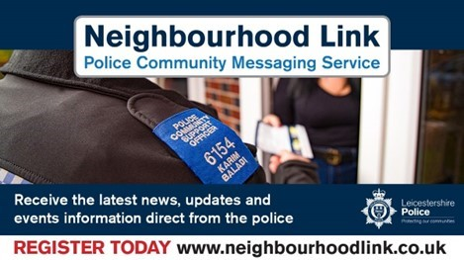

Neighbourhood Link is a community messaging service from Leicestershire Police that provides news and
Information about policing activity or initiatives, crime prevention advice as well as major incidents affecting your area.
Through this service you can receive messages from your local Neighbourhood Policing Team, local police or, in the event of a major incident or event affecting the whole of Leicestershire, from a partnership of agencies known as the Local Resilience Forum.
In order to receive messages you will need to register your details. Registration is free and simple to follow.

- Sign up to Neighbourhood Link https://www.neighbourhoodlink.co.uk/
- If you are already registered you can amend your details
- Request a reminder if you have forgotten your username or password • You can unsubscribe from the service at any time

Do you use a ‘community whatsapp group’? If so please consider sharing neighbourhood link information on there to encourage others to join.
Neighbourhood Link is not able to receive messages and you should not use it to contact the police. In an emergency always dial 999. If you wish to contact Leicestershire Police in other circumstances, for example to speak to local police or seek advice on police matters, you can call us by dialling 101 on your telephone.
•If you are already registered you can amend your details
•Request a reminder if you have forgotten your username or password
•You can unsubscribe from the service at any time
Neighbourhood Link is not able to receive messages and you should not use it to contact the police. In an emergency always dial 999. An emergency is when a crime is happening, someone suspected of a crime is nearby, someone is injured, being threatened or in danger.

If you wish to contact Leicestershire Police in other circumstances, for example to speak to local police or seek advice on police matters, you can call us by dialling 101 on your telephone.

