FOREST BEAT NEWSLETTER
#YouSaidWeDId

Issue: June 2024
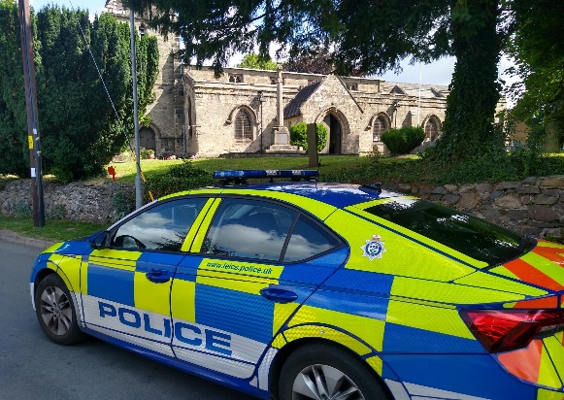
Your Local Team

- PS 4704 Cat Fletcher
- PC 1389 Russ Leech
- PC 1234 Owain Jones
- PCSO 6686 Maddie Fearn

Your Dedicated Neighbourhood Team (DNT) is a group of local police officers dedicated to serving your community. The team is made up of officers based in your area, supported by the wider Policing family.

What matters to you

Your priorities are chosen quarterly and are based upon information gathered through NHL (Neighbourhood Link), social media, local engagement, and emerging crime trends. You have stated that the following key themes are important to you. #YouSaidWeDid

Priority 1: Theft & attempt theft of vehicles in Measham, Moira and Donisthorpe

You Said: Reports of criminals stealing from or interfering with cars have risen and this has become a concern for you.

What we have been doing: Intensive and targeted mobile and foot patrols of the areas affected, with officers looking to utilize stop and search powers where justified. We continue to develop our intelligence picture around those who commit crime so we can target our resources to eﬀectively impact on criminals. We speak to residents and offer reassurance.

Priority 2: ASB & Drug use at Moira Furnace/Moira Miners Welfare Club

You said: Anti-social behaviour and drug users are causing you concern, particularly at Moira Furnace and Moira Miners Welfare Club.

What we have been doing: Targeted foot patrols of the area and regular beat surgeries held at the Furnace. Whilst we will robustly deal with those who break the law, we will also seek to engage with the drug users to understand what factors are driving them to this lifestyle and what interventions we can oﬀer. Officers work alongside partner agencies to ensure the best service provider is in place to try and mitigate risk and open drug use.

Priority 3: Drug Dealing in Oakthorpe and Donisthorpe

You said: Drug dealing is taking place in Oakthorpe and Donisthorpe

What we have been doing: Regular patrols of areas that are of concern to you. We work with our partners to help remove the problem. Liaise with partner agencies and conduct patch walks of the areas. Officers look to develop intelligence around those dealing drugs and will look to take action accordingly. If you have information, you can report it anonymously at Independent UK charity taking crime information anonymously | Crimestoppers (crimestoppers-uk.org)
Crime Figures

To find out about crime that occurs within your area, please use the below link.

Forest | Police.uk (www.police.uk)
Note: published crime and anti-social behaviour data will exceed 30 days old
What we have done #YouSaidWeDid
The work of officers and staff in Leicestershire to prevent and investigate knife crime was highlighted during a national week of action. OP SPECTRE ran from 13-19th May, police up and down the county have been taking part in the fight against knife crime. Some of this activity will be more discreet, with officers looking and progressing local intelligence, others will include anti-knife crime activities/inputs with local groups and schools, knife sweeps on local parks and areas.
After attending a beat surgery held at Moira Furnace a local resident expressed concerns regarding speeding on Measham Road in Moira, speed checks were conducted in May and out of 35 vehicles that passed by 4 were travelling over the 30mph speed limit, these drivers were issued with warning letters.
Oﬃcers have been out on proactive patrols which has led to them issuing several verbal warnings to certain people who have committed antisocial behaviour at Moira Miners Welfare Club and Moira Furnace.
Officers assisted members of North-West Leicestershire District Council Housing Department with the closure of an address on the beat where there has been a particularly high number of complaints.
Whilst out on patrol officers noticed a motorbike being driven erratically, after investigation the owner of the motorbike was found to be disqualified from driving. The motorbike was seized, the rider has been reported for the relevant traffic offences which will result a court appearance.
Officers conducted a patch walk in Measham along with member of the Parish Council and ASB officers from North-West Leicestershire District Council
Officers attended Moira Canal Festival which took place on the weekend of 18th and 19th May. The event was very well attended, and the weather was beautiful. Live music and Morris dancing took place along with lots of craft and trade stalls. There was the annual duck race and even a flyover by a spitfire! On the Saturday officers had a stall and gave away lots of freebies! Thank you to everyone that popped to see us.

Page 2

Community Engagements

Saturday 15th June – Moira Furnace – 2pm till 4pm
Thursday 20th June – AGE UK – 10.30am till 12 midday
Friday 28th June – Donisthorpe Woodlands Centre – 10.30am – 12 midday

Page 3

Your Views Survey
NEIGHBOURHOOD LINK:
Neighbourhood Link is a community messaging service from Leicestershire Police that provides news and information about policing activity or initiatives, crime prevention advice as well as major incidents affecting your area. In order to receive messages, you will need to register your details. Registration is free and simple to follow.
- Sign up at: https://www.neighbourhoodlink.co.uk
- Already have an account? Simply request a reminder if you have forgotten your username or password
- You can unsubscribe from the service at any time
Neighbourhood Link is not able to receive messages and you should not use it to contact the police. In an emergency always dial 999. If you wish to contact Leicestershire Police in other circumstances, for example to speak to local police or seek advice on police matters, you can call us by dialling 101 on your telephone or using any of the below sites.
Please also take the time to let the Forest Beat understand your concerns by completing the surveys to the right. Simply scan your camera over the top and click the link.

Confidence Survey

